1.Joint plot (Reading Scores by Parental Level of Education):
The joint plot displays a scatter plot of reading and writing scores. It helps to visually assess the relationship between the two variables, showing a positive correlation.
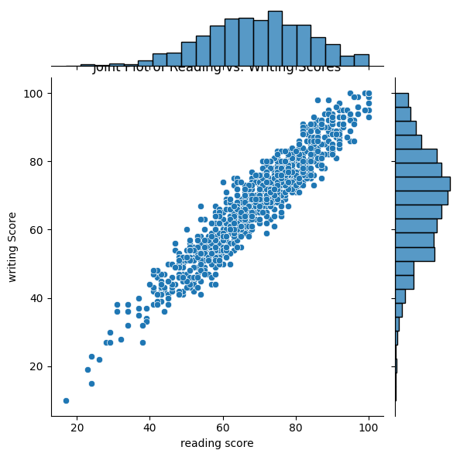

2. Heatmap (Correlation Matrix): The heatmap shows the correlation between math, reading, and writing scores. It visually represents the strength and direction of the relationships, with a high positive correlation between all three.
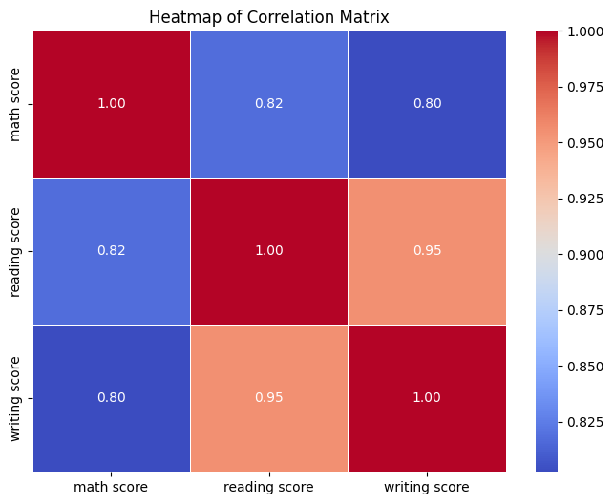

3. Box plot with Swarm Overlay (Math Scores by Parental Level of Education): The box plot shows the distribution of math scores for each parental education level, with the swarm overlay providing individual data points for a more granular view of score spread within each category.

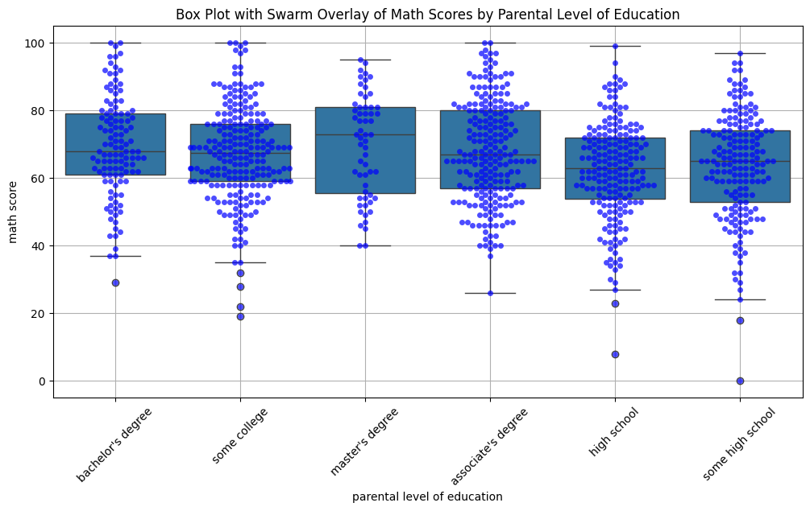
4. Violin plot (Math Scores by Gender):: The violin plot shows the distribution of math scores for each gender, providing insights into the density and spread of scores within the two groups.

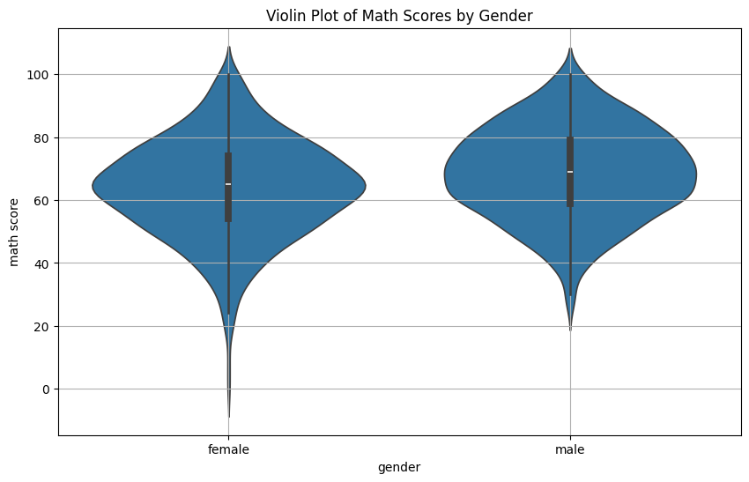

5. Pair Grid (Math, Reading, and Writing Scores): The PairGrid displays the relationships between math, reading, and writing scores. Scatter plots on the upper diagonal, KDE plots on the lower diagonal, and histograms with KDE on the diagonal offer a detailed view of the distributions and correlations.
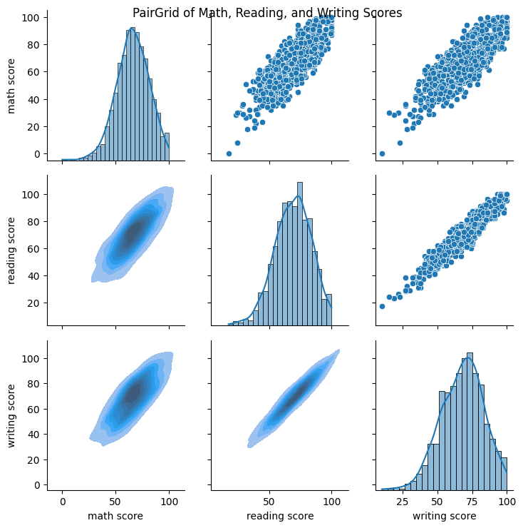

6. Swarm plot (Reading Scores by Parental Level of Education):
The swarm plot highlights individual reading scores grouped by the parental level of education, offering a comparison of the spread and clustering of scores for each education level.
